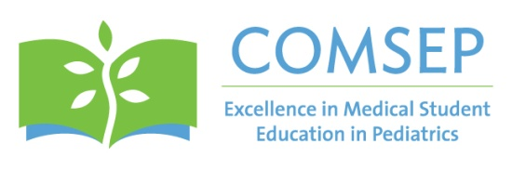

Executive Office: 6728 Old McLean Village Drive • McLean, VA 22101-3906 • (703) 556-9222 • FAX (703) 556-8729
info@comsep.org • www.comsep.org

Update for Pediatric Department Chairs--Fall 2014

COMSEP Grants Program

These $5000 grants are provided to support, enhance and expand educational scholarship on the part of COMSEP members. The grant project provides a unique opportunity for members to creatively address a topic or problem of interest at their institution, or collaboratively work across institutions. The scope of the proposed work should be focused and feasible in a two-year project period. The topic or question addressed should be one of relevance to many pediatric educators, so that the findings might yield new educational methods or promising tools, or perhaps inform best practices in pediatric medical education. All applicants are given feedback on their proposal by an experienced group of medical educators who comprise the selection committee. Grant recipients are provided mentorship throughout the project period. Grant Award- $5000 – consisting of $2500 from COMSEP and $2500 from sponsoring department.

Deadline to apply-December 4, 2014. Apply at http://www.comsep.org/grants/login.cfm

Questions- contact COMSEP Grant Committee Chair, Dr. Janet Fischel, at janet.fischel@stonybrookmedicine.edu

COMSEP Awards Program

The goal of this national award program is to honor members who have made substantial contributions in the areas of teaching/education, research/scholarship, and clerkship administration. In addition, a COMSEP Achievement Award exists to recognize a current or former COMSEP member who has made contributions of great significance to COMSEP and its membership.

More information about the awards, past recipients and the application can be found at: http://www.comsep.org/scholarlyactivities/awards.cfm

Deadline-December 15, 2014

COMSEP Membership and Dues

In August 2014 COMSEP was granted independent 501c3 not for profit status. COMSEP will continue to have the same mission and provide the valuable opportunities for educational enhancement that our members have appreciated in the past. Our new proposed membership fees are based on individual membership, and are similar to other national organizations of medical educators.

Starting January 2015
- Dues will be collected on an individual basis (rather than institutional membership)
- Dues will be collected on a calendar year (rather than an academic year) with notices going out in November-starting November 2014 for the 2015 calendar year.
- Membership confers significant savings toward the COMSEP Annual Meeting registration fee.

Membership Designations and Annual Membership Dues
Faculty: $300
Administrators: $100
Trainees: $50
Emeritus (retired): $50

Please contact COMSEP President Dr. Michael Barone with any questions: mbarone@jhmi.edu

